

STUDENT CASE STUDY EXECUTION REPORT

Department | FED
Subject | DSA-2
Academic Year | I-III Semester (2025-26)
Faculty Name | P Swethanagasri
Student Name | Hamsini Cherukuri
Roll Number | 2520030016
Branch | CSE
Course Outcome | Analyze multi-way search trees (B-Trees ,B+ Trees )and Range Query structures(Segment and Fenwick Trees)
Case Study Topic: Duck DB Columnar Storage – Zone Map (Skip Index)

Work Done Summary:

A zone-map (skip index) was created by storing the minimum and maximum timestamp for each data block. During query execution, blocks whose ranges do not overlap the query range are skipped, reducing unnecessary disk reads and improving performance.

Implementation Details:

Divide the table into data blocks so that each block contains a fixed number of rows.

Create a Zone Map by storing the minimum and maximum timestamp value for every block.

Store the Zone Map metadata separately from the actual table data.

Receive the query containing a timestamp range (e.g., BETWEEN start_date AND end_date).

Compare the query range with each block's min-max range in the Zone Map.

Skip blocks whose timestamp ranges do not overlap with the query range.

Read only the overlapping blocks that may contain the required records.

Retrieve the matching rows from the selected blocks.

Return the query result to the user.

Achieve faster query execution by reducing the number of blocks read from storage.

Result: Screenshots / Output

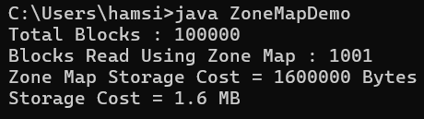

Zone Maps require only 1.6 MB of additional storage and significantly reduce disk I/O for clustered data. For random data nearly all blocks are accessed, whereas for clustered timestamp ranges only about 1% of blocks are read. Therefore, columnar databases use sort-on-write (clustered ingestion) to maximize zone-map efficiency and achieve faster query performance.

GitHub Link: https://github.com/hamsini0709/DuckDB-Columnar-Storage-Zone-Map-Skip-Index-

